**Unveiling Sales Trends with Tableau**

Name

Institution

Date

**Introduction**

Today, business decisions are increasingly data-driven and such insights play a critical role in helping enterprises to make informed and strategic decisions to remain competitive. This report leverages the power of Tableau's data visualization capabilities to explore sales performance across geographic regions, product lines, and customer segments. The report addresses three key research questions: 1) What are the sales performance in different geographic regions? 2) Which product lines generated the highest income? 3) Is there any relationship occurring between the deal sizes and sale revenue?

**Methodology**

The analytical task was done by Tableau, which is a popular business intelligence and data visualization tool. The software received geographical regions, product lines, and scale of the deal, among other variables as sales data inputs. Interactive visualizations, such as maps, bar charts, and pie charts were used to derive meaningful insights, patterns, and correlations. The dataset was obtained from <https://www.kaggle.com/datasets>.

**Results**

Based on the initial research question, the regional analysis revealed that countries like the United States ($3,627,983) and Spain ($1,215,687) topped the list of sales.

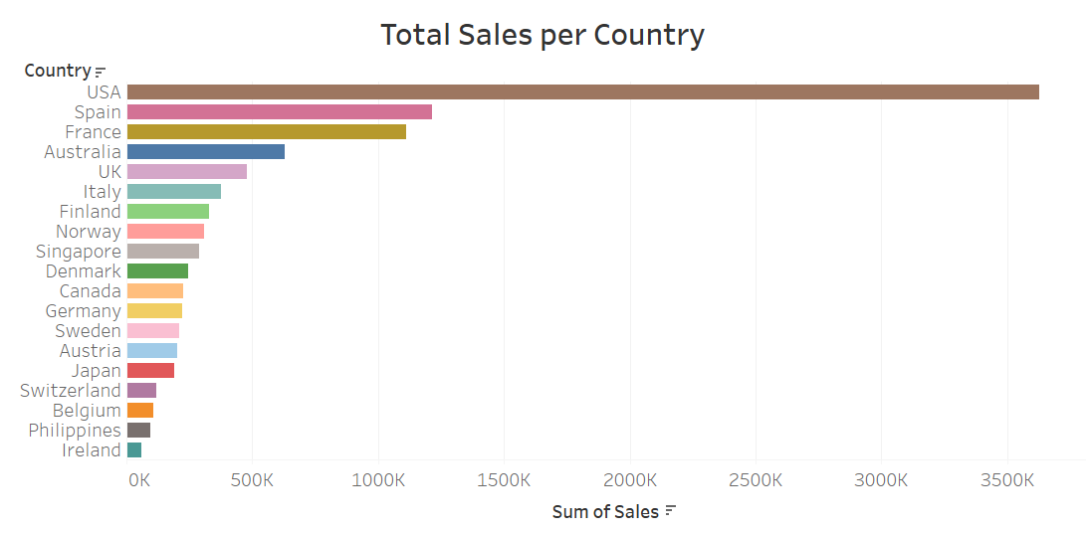

On the other hand, Belgium ($108,413), the Philippines ($94,016), and Ireland ($57,756) recorded the lowest sales revenues.

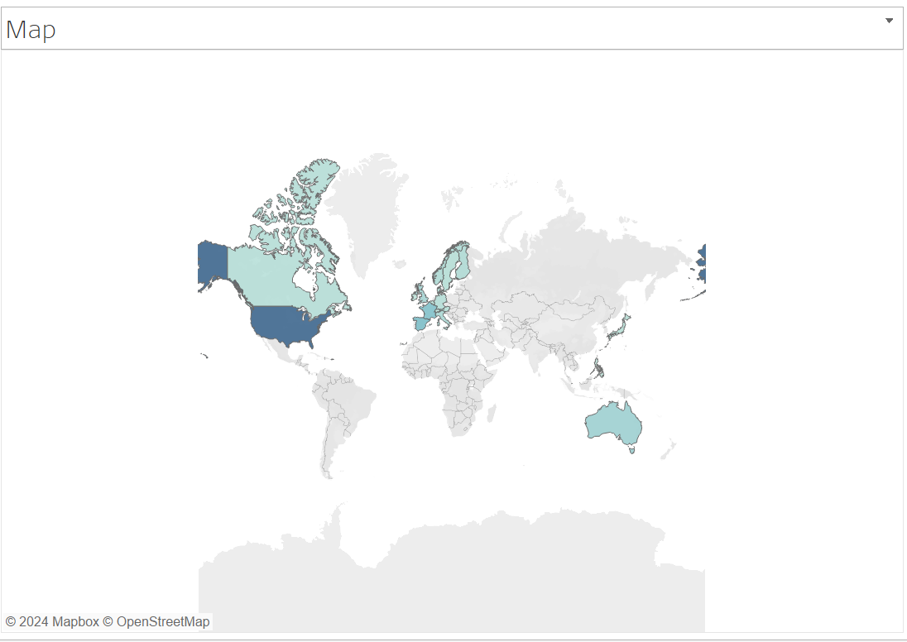

For the second research question, the Classic Cars ($3,919,616) and Vintage Cars ($1,903,151), are the product lines that recorded the highest revenue. They were followed by Motorcycles ($1,166,388) and Truck and Buses ($1,127,790).  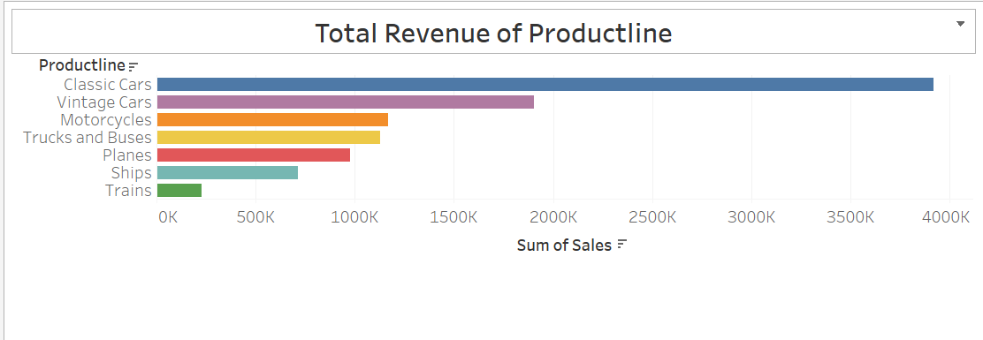

The third question, in turn, revealed a relatively low correlation between deal size and sales, with Medium-sized ones constituting the highest sales revenue ($6,087,432). The Small-sized deal recorded a total revenue of $2,643,077 while the Large-sized deal recorded $1,302,119.

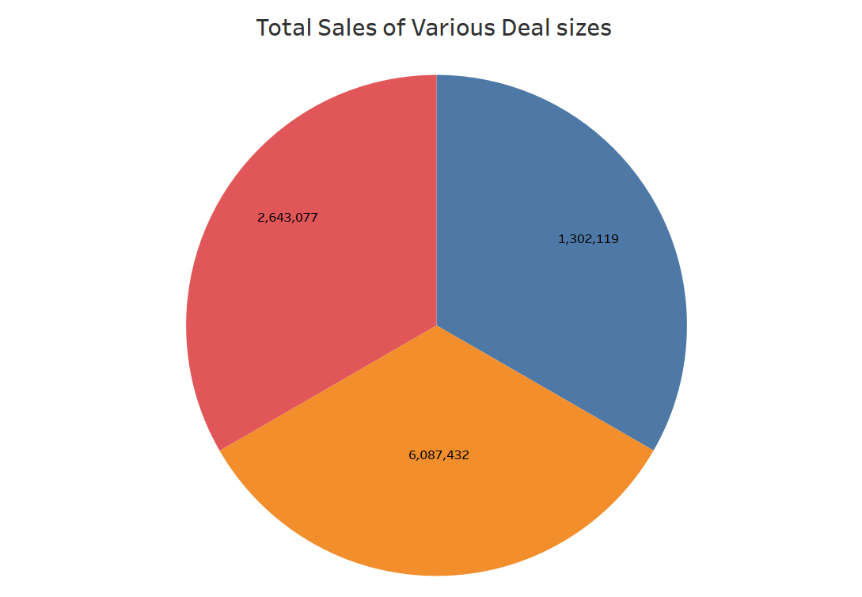

**Conclusion**

This descriptive analysis has given us significant information about sales results regarding the geographical regions, product lines, and customer segments. According to the analysis, it is advisable to pay the most attention to the top-performing regions and allocate resources to them accordingly. Besides this, emphasis should be on the most profitable product lines and carving out customized marketing strategies for the respective customer segments that help upscale earnings. Continuous monitoring and analysis of sales data is a vital aspect of keeping pace with dynamic market dynamics while securing a competitive edge.

**Reference**

<https://www.kaggle.com/datasets/kyanyoga/sample-sales-data/data>

**Appendices**

**Sales Dashboard**

